CERTIFICATE

This is to certify that the Project Report submitted by JITENDRA CHAUDHARY (22SE02ML095) to the P P SAVANI UNIVERSITY for the partial fulfilment of the subject credit requirements is a bonafied work carried out by the student.

This is to further certify that I have been supervising the Major/Minor Project of JITENDRA CHAUDHARY (22SE02ML095).

The contents of this report, in full or in parts, have not been submitted to any other Institute or University for award of any degree, diploma or titles.

Sign of Faculty Mentor :

Name of Faculty Mentor :

Date:

ACKNOWLEDGEMENT

This report would not have been possible without my teachers who were always there when I needed them the most. I take this chance to acknowledge them and extend my sincere gratitude for helping me make this Report a possible.

I wish to thank my faculty mentor Ms. Shruti Mishra, Assistant Professor, School of Engineering. It has been an honor to learn under their mentorship.

As my mentor, she has constantly motivated me to remain focused on achieving my goal. Their observations and guidance helped me to establish the overall direction of the report and to move forward with learning in depth. Their vital support at each juncture, which culminated in successful completion of my project work. I express my sincere gratitude to them for constant support during the project work.

I am also thankful to faculty members of the department for constant support and guidance.

I am thankful to Dean, School of Engineering for his initiative of imparting Project during tenure of your study making us learn new things and to help us in expanding our horizons.

Name of Student : JITENDRA CHAUDHARY
Enrollment No : 22SE02ML095

ABSTRACT

The project “Personalised Career Recommendation and Skills Growth Tracker using AI” aims to assist individuals in identifying the most suitable career paths and skill development opportunities based on their personal interests, skills, experience, and salary expectations. The system leverages Artificial Intelligence (AI) and Natural Language Processing (NLP) to analyse both user input and real-world job data. Using the Sentence Transformer model (all-MiniLM-L6-v2), the system generates embeddings for job descriptions and user profiles to measure similarity through cosine similarity. A Random Forest Classifier is then used to predict job suitability and recommend the most relevant roles.

The model evaluates various parameters such as job titles, industries, experience levels, required skills, and salary ranges. Users interact with the system through a simple web interface, and the backend processes their input to generate personalized recommendations. This AI-driven approach bridges the gap between users’ current skills and career goals, helping them make informed decisions while promoting continuous professional growth.

Table of Contents
1. Introduction vii
1.1 Objective vii
1.2 Scope viii
1.3 Project Goals viii
2. System Analysis viii
2.1 Identification of Need viii
2.2 Preliminary Investigation viii
2.3 Feasibility Study ix
2.4 Project Planning ix
2.5 Project Scheduling x
2.6 Software requirement specifications (SRS) xi
2.7 Software Engineering Paradigm applied xii
2.8 Data models and Diagrams xiii
3. System Design xiv
3.1 Modularization details xv
3.2 Data integrity and constraints xv
3.3 Database design xvi
3.4 User Interface Design xvi
3.5 Test Cases xviii
4. Coding xxi
4.1 Database Creation and Management xxi
4.2 Complete Project Coding xxii
4.3 Comments and Description of Coding segments xxiii
5. Standardization of the coding xxiv
5.1 Code Efficiency and Error Handling xxiv
5.2 Parameter Calling / Passing xxv
5.3 Validation Checks xxvi
6. Testing xxviii
7. System Security Measures xxxii
8. Cost Estimation of the Project xxxiii
9. Reports xxxiv
10. Future Scope and Further Enhancements xxxv
11. Bibliography xxxvi
12. Appendices xxxvii
13. Glossary xxxix
14. References xli

Introduction

1.1 Objective
Choosing the right career has become difficult due to the growing number of job roles and fast-changing industry demands. Many students and professionals struggle to match their skills and interests with suitable job opportunities. Traditional counselling or keyword-based systems cannot provide accurate, personalized guidance.
This project, “Personalized Career Recommendation and Skills Growth Tracker using AIML,” aims to solve this problem by using Artificial Intelligence and Machine Learning. The system analyzes the user’s interests, skills, experience, profession preference, and salary expectations. It then compares this information with a job dataset using Sentence Transformer embeddings, cosine similarity, and Random Forest classification to recommend the most suitable career paths. The system also highlights required skills for each recommended role, helping users understand their strengths and areas of improvement.

1.2 Scope
The scope of this project includes collecting and preprocessing a career-related dataset, training a recommendation model using machine learning techniques, and integrating the model into a web-based platform. Users can input their skills and receive personalized job role suggestions along with skill improvement guidance. The system focuses on entry-level to mid-level job recommendations and is designed for students, fresh graduates, and individuals exploring new career options. The scope does not include real-time market analysis or advanced HR-level recruitment features.

1.3 Project Goals
- Develop a functional machine learning model that predicts suitable career roles based on user input.
- Design a user-friendly web interface where users can submit their details easily.
- Provide skill improvement suggestions for each recommended job role.
- Create a backend system that connects the trained model with the website.
- Ensure accurate predictions by preprocessing and training on a relevant dataset.
- Offer a smooth user experience with instant, personalized recommendations.
- Deliver a complete project report and documentation following academic guidelines.

System Analysis

2.1 Identification of Need
Students and professionals often struggle to select the right career path because of limited guidance and the vast number of available job roles. Manual counselling is time-consuming and subjective, while traditional job portals provide generic suggestions.
Therefore, a system is needed that can analyze user skills, interests, and experience and match them with real job data using AI for accurate, personalized career recommendations.

2.2 Preliminary Investigation
During the initial research stage, it was found that no reliable or practical career recommendation system existed for students or freshers. Most available tools online were either too generic or only suggested jobs based on simple keyword matching.
Further investigation showed that some students had created similar projects, but:
- They were developed only for academic purposes.
- The systems were poorly trained with very small datasets.
- Recommendations were not accurate or personalized.
- Many models failed to consider skills, experience, or salary expectations.
- A few projects were incomplete and did not work properly when tested.
This highlighted the need for a more advanced, usable, and intelligent system that uses real datasets, proper NLP embeddings, and machine learning for accurate predictions.

2.3 Feasibility Study
- Technical Feasibility
- Python and libraries like Sentence Transformer, Scikit-learn, Flask are easily available and suitable.
- Dataset is structured and ready for preprocessing.
- Model can run on normal systems without GPU.

- Operational Feasibility
- System is easy to use through a simple web interface.
- Users only need to input interests, skills, profession, salary, and experience.

- Economic Feasibility
- Uses open-source tools → no extra cost.
- Low operational expense as system can run locally or on low-cost servers.

2.4 Project Planning
The project was planned in the following phases:
- Dataset Collection & Cleaning
- Embedding Generation using Sentence Transformer
- Model Training using Random Forest
- Similarity Calculation & Hybrid Scoring
- Backend Development (Python + Flask)
- Frontend UI Development (HTML, CSS, JS)
- Testing & Refinement
- Documentation and Report Writing

2.5 Project Scheduling

PERT Chart-

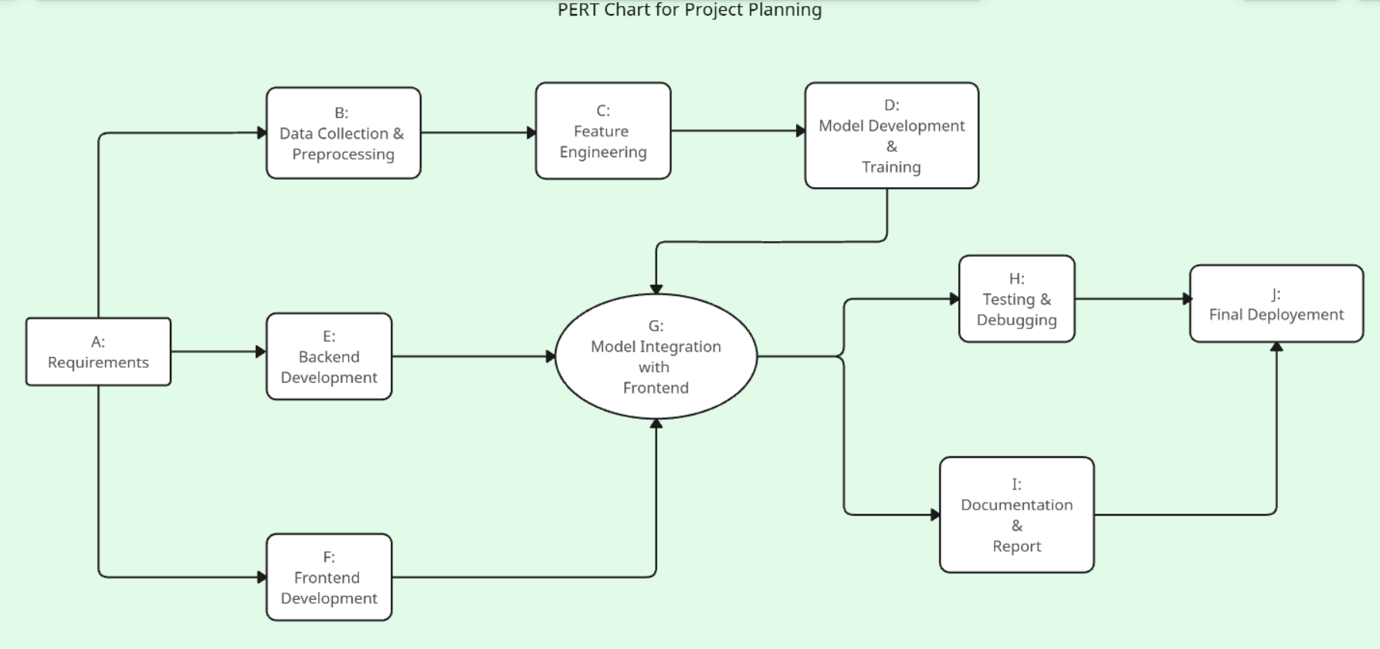

Gantt Chart-
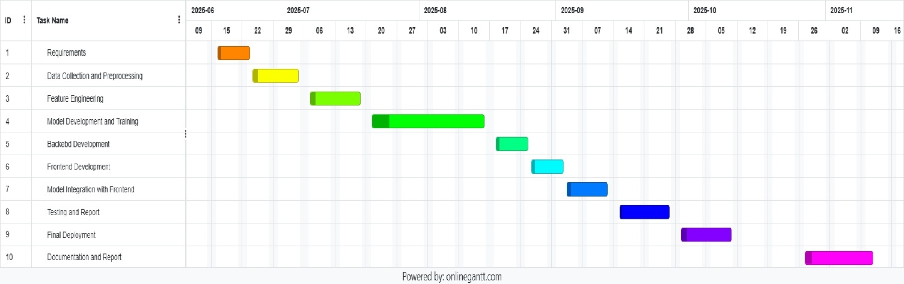

2.6 Software requirement specifications (SRS)

Functional Requirements
- User can enter interests, skills, profession, experience, and salary.
- System generates embeddings for user input.
- Model compares user data with job dataset.
- System provides top 5 job recommendations.
- System displays required skills for each job role.

Non-Functional Requirements
- Performance: Fast inference (text embeddings computed quickly).
- Accuracy: Hybrid scoring (ML + cosine similarity).
- Usability: Simple and clean web interface.
- Security: Limited access to stored model and data.

Software Requirements
- Python 3.x
- Sentence Transformer
- Scikit-learn
- Flask
- Pandas, NumPy
- HTML, CSS, JavaScript

2.7 Software Engineering Paradigm applied
For this project, the Iterative Software Development Model was used. This model was ideal because the system involved machine learning, data preprocessing, and a web interface—features that require continuous testing and improvement.
In each iteration, a small but complete part of the system was developed, tested, and refined. Early iterations focused on dataset cleaning and generating embeddings. Later iterations worked on training the machine learning model, integrating it with the website, testing recommendations, and improving user experience.

The iterative approach allowed:
- Step-by-step improvements
- Easy debugging and refinement
- Better accuracy of the ML model
- Flexibility to modify features based on feedback
Overall, the paradigm ensured a stable, accurate, and user-friendly career recommendation system.

2.8 Data models and Diagrams
1. Data Flow Diagram
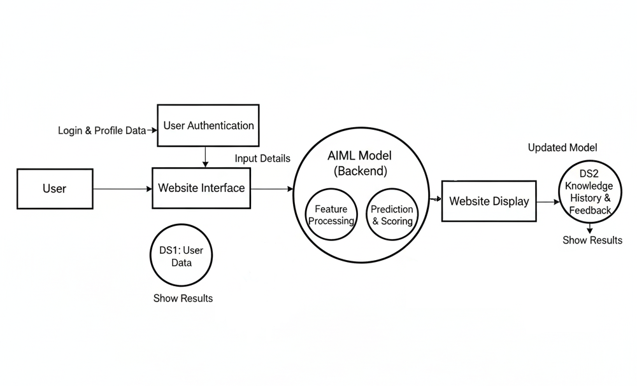

2. Flow Chart
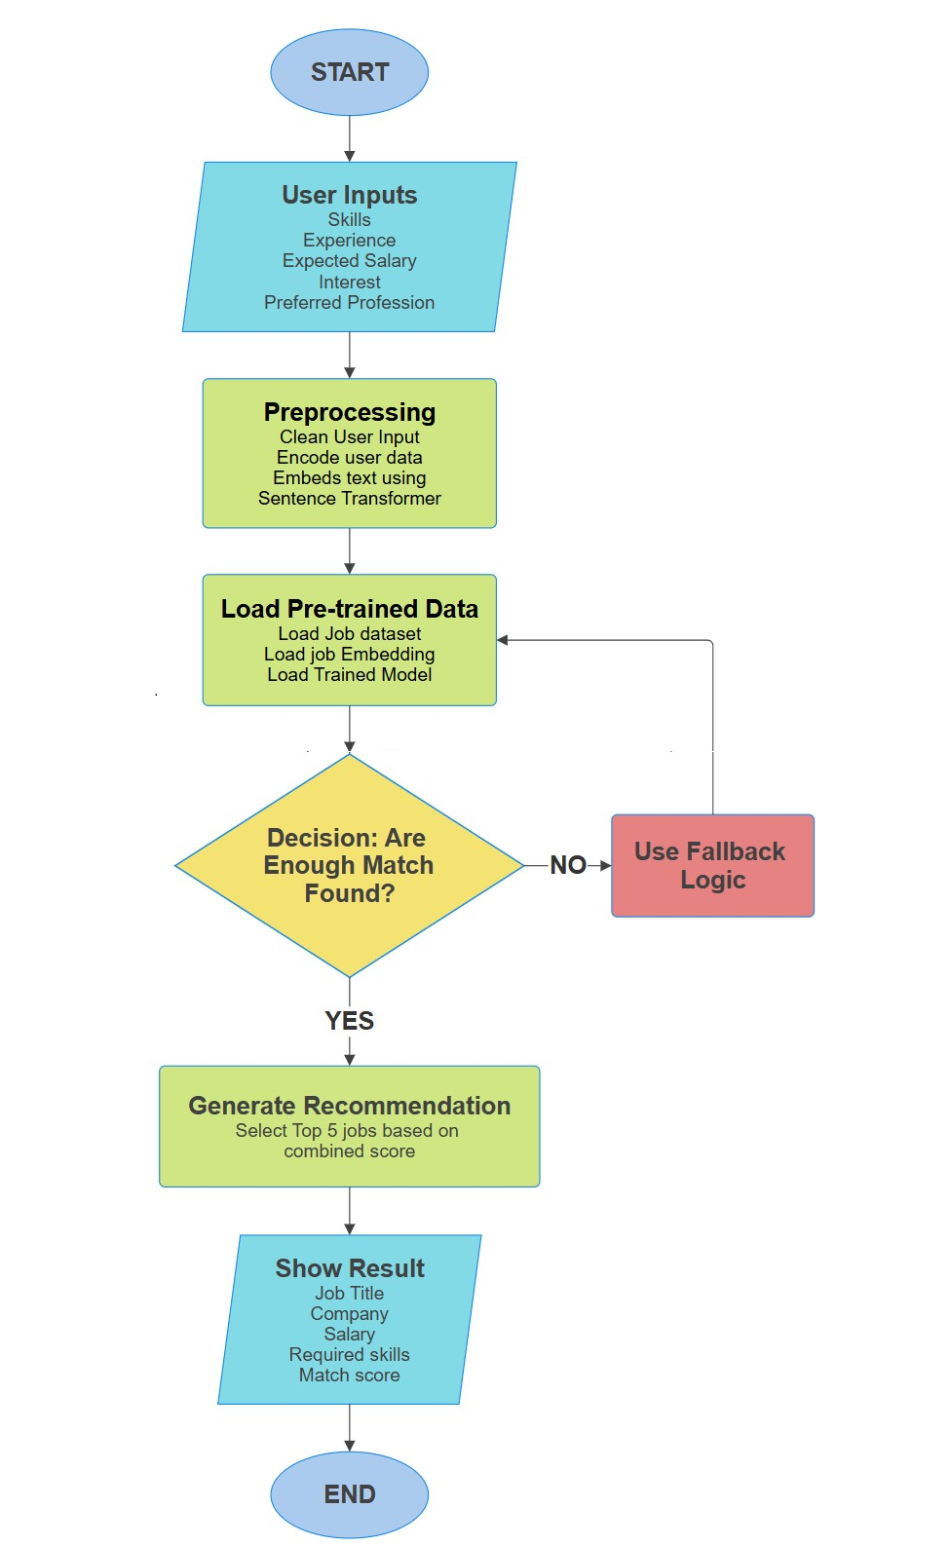

System Design

3.1 Modularization details
Your project is divided into clear, independent modules that work together to provide career recommendations and skill-growth tracking.
Modules:
- User Management Module
- Handles registration, login, authentication.
- Stores user details and preferences.
- Data Collection Module
- Collects user inputs such as skills, interests, education, experience.
- Machine Learning Module
- Loads trained model.
- Predicts the best career fields based on user profile.
- Generates confidence scores.
- Recommendation Module
- Career suggestions
- Required skills for chosen career
- Learning resources
- Database Management Module
- Stores user data, skills, recommended careers, progress.
- Skill Progress Tracking Module
- Tracks improvements in skills.
- Updates learning progress.
- Web Interface Module
- Frontend UI for user interaction with the system.
Each module is designed so if one part is updated (e.g., ML model), the rest remains unaffected.

3.2 Data integrity and constraints
Data integrity ensures that all information stored in the system remains accurate, consistent, and reliable. The project maintains integrity through a combination of database-level constraints and application-level validations.
Key constraints applied include:
- Primary Keys:
Every main table (Users, Skills, Careers) has a unique identifier to prevent duplicate entries.
- Foreign Keys:
Used in linking tables such as UserSkills and Recommendations to maintain relationships between users and careers.
- Domain Constraints:
Fields like skill level (0–100), experience (in years), and email format follow strict validation rules.
- Not-Null Constraints:
Critical fields such as user name, email, and selected skills must be filled before submission.
In short, these constraints ensure that only clean, meaningful, and validated data is stored, which improves the performance and accuracy of the AI/ML recommendation model.

3.3 Database design
The database for this project is designed using SQLite with Flask-SQLAlchemy (ORM), which provides a structured and scalable way to store user information and their career-related details. The design follows a relational model, ensuring that data is organized, connected, and easy to retrieve.
At the core, the system contains two main tables:
- Users
- Career Profiles
These two tables are linked using a one-to-one relationship, where each user can have only one career profile. This separation keeps authentication data and professional details independent and well-organized.

3.4 User Interface Design
The user interface of the Personalized Career Recommendation and Skills Growth System is designed to be simple, clean, and easy to navigate. Since the target users include students and job seekers, the UI focuses on clarity and smooth flow from registration to receiving recommendations. The system consists of five main screens: Home Page, Create Account Page, Login Page, Get Recommendation Page, and the Dashboard for Profile Completion.
- Home Page
This is the first screen the user sees, and it introduces the purpose of the system.
Key elements include:
- A simple title and description of the project
- Buttons for Login and Create Account
- A visually clean layout to guide first-time users
The Home Page sets the tone of the application and helps users understand what the system offers even before logging in.
- Create Account Page
This page allows new users to register before accessing the system.
It typically contains:
- Input fields such as Name, Email, Password
- A “Create Account” button
- A small link redirecting to Login if the user already has an account
The UI focuses on clarity and error-free input, ensuring smooth onboarding.
- Login Page
Registered users can log into the system through this interface.
The page includes:
- Email and Password fields
- A Login button
- A clean minimal UI to reduce distractions
This page acts as a secure entry point ensuring only authenticated users can access the system.

- Start Getting Recommendation Page
After logging in, users are taken to the Get Recommendation screen.
This page consists of:
- A brief message introducing how recommendations will be generated
- A button such as "Start Recommendation" or "Proceed"
- A simple layout that encourages users to continue to the dashboard
This page acts as the transition point from login to skill/career evaluation.
- Dashboard (Profile Completion Page)
The Dashboard is one of the most important UIs, as users provide details required for generating personalized career recommendations.
The interface includes:
- Fields for entering personal details, current skills, education, and interests
- A submit/update button
- Profile completion indicators (optional)
The dashboard is designed to be user-friendly so that the user can easily provide all necessary information without confusion. Once the details are completed, the system uses this data for generating recommendations.

Test Cases
- Unit Testing
Unit testing focuses on testing individual components or modules of the system to ensure each part works independently.
In your Personalized Career Recommendation System, unit tests check small parts like:
- Input validation functions
- Login function
- Registration function
- Recommendation logic
- Profile update logic
- Form validation (email, password strength)
The goal is to ensure each function behaves correctly before integrating them together.
Test ID | Component | Test Description | Expected Output
UT-01 | Registration Form | Test with empty username/email/password | System shows error: “All fields are required”
UT-02 | Login Function | Test login with correct credentials | User successfully logged in
UT-03 | Login Function | Test login with incorrect password | Error message displayed
UT-04 | Profile Form | Test saving profile with valid data | Profile information stored in database
UT-05 | Recommendation Module | Test recommendation function with valid user input | System generates career suggestions

- System Test Cases
System testing validates the entire system as a whole.
Here, the goal is to ensure:
- All modules work together properly
- The workflow is smooth
- There are no integration issues
- User journey is consistent
System testing covers complete operations from registration → login → profile setup → recommendation generation.

Test ID | Scenario | Input / Action | Expected Result
ST-01 | User Registration Flow | User completes registration form | Account created and redirected to login
ST-02 | Complete Workflow | Register → Login → Fill Profile | System works smoothly and moves to dashboard
ST-03 | Profile Completion | User submits incomplete profile | System shows: “Please complete all required fields”
ST-04 | Recommendation Generation | User submits complete profile | System displays recommended career options
ST-05 | Logout | User clicks logout | User session ends and redirected to home/login

Coding
The coding phase of the Personalized Career Recommendation System involves implementing the backend logic, machine learning model, database operations, and frontend web interface. The project follows a modular structure where each functionality is separated into different Python modules and HTML templates, ensuring clarity, maintainability, and reusability.

Database Creation and Management
Even though the project uses a lightweight database structure, it plays an essential role in storing and managing user information. The database creation process involves defining the required tables, applying essential constraints, and ensuring reliable data access.
Key elements included in database creation:
- User Table: Stores user credentials, ensuring unique email constraints and secure password handling.
- Profile Table: Contains skills, education, experience, and other inputs needed for recommendation.
- Constraints:
  - Email must be unique
  - Mandatory fields must be filled
  - Valid data formats must be maintained
- Data Insertion:
  - Occurs during user registration
  - Happens when users update their profile
- Access Rights:
  - Only authenticated users can access the dashboard and recommendations
  - Sensitive information is protected through backend-level access control
Overall, the database layer supports the proper functioning of user registration, login, and career recommendation workflows.

Complete Project Coding
Project coding is divided into three major components:
- Frontend Development
The user interface is developed using HTML, CSS, and supportive scripts.
It includes pages for:
- Home/landing page
- Account creation
- Login
- Dashboard for profile editing
- Recommendation module
The layout follows a clean, simple, and user-friendly design to ensure smooth navigation.
- Backend Development
The backend manages:
- User registration and authentication
- Input validation
- Communication with the database
- Processing of profile information
- Generating career recommendations using the ML model
The backend follows a structured and modular architecture, separating routes, logic, and database operations clearly.
- Machine Learning Module
A machine learning model is prepared using a structured dataset.
The model performs:
- Data preprocessing
- Feature extraction
- Training and evaluation
- Prediction of suitable job roles
The trained model is integrated into the backend so that the user receives recommendations instantly through the dashboard.

Comments and Description of Coding segments
The codebase is documented with meaningful comments explaining the purpose and function of each segment. This improves understanding and simplifies future updates.
Documentation Highlights:
- User authentication logic is commented to explain validation flow.
- Profile processing section includes comments describing data extraction for the ML model.
- Recommendation module is documented to explain prediction handling.
- UI templates include comments for layout structure and dynamic data rendering.
The presence of clear comments ensures that other developers or evaluators can easily understand how each part of the system works.

Standardization of the coding
The coding for the Personalized Career Recommendation System follows a structured, modular, and optimized development methodology. The aim is to ensure that every component—backend logic, machine learning integration, database operations, and user interface interaction—maintains consistency, reliability, and performance. The system is designed using clean coding principles, predictable architecture, and reusable functions that make the entire project easier to scale and maintain.

Code Efficiency and Error Handling
The complete system is built with efficiency and robustness in mind. The backend, machine learning module, and user interface are designed such that response time remains minimal while maintaining accuracy and stability.
  - Code Efficiency
- Modular Architecture:
Every major functionality—user authentication, profile processing, recommendation generation, and database interaction—is separated into independent modules. This reduces complexity and makes the code scalable and easy to debug.
- Optimized Database Interaction:
Queries are executed using efficient ORM operations, reducing repeated database calls and ensuring fast access to user and profile data.
- Model Preloading for Recommendations:
The career recommendation model and preprocessing steps are initialized once and reused.
This avoids repeated loading and ensures instant response when the user requests recommendations.
- Lightweight Backend Processing:
The model runs on CPU-friendly algorithms, eliminating the need for expensive hardware while still maintaining good prediction quality.
- Efficient Data Flow:
User inputs are validated, processed, and passed through the ML pipeline in a streamlined manner without unnecessary conversions or redundant computations.
  - Error Handling
To ensure that the system never crashes unexpectedly, multiple layers of error handling are applied throughout the application.
- Backend-Level Error Handling:
  - Login errors (invalid credentials)
  - Registration errors (duplicate username/email)
  - Missing or incomplete profile data
  - Failed database updates
  - Server errors such as incorrect routing or missing templates
- ML Pipeline Error Handling:
  - Prevents failures due to empty user inputs
  - Handles unexpected data types or missing fields
  - Ensures model outputs are safely returned even if certain values are missing
- User-Friendly Messages:
When errors occur, users see helpful and meaningful messages rather than technical traces. This improves overall usability and smoothens the user experience.
- Fallback Handling:
If the recommendation model encounters invalid or insufficient data, the system provides a safe fallback response rather than terminating the session.

Parameter Calling / Passing
The project maintains a clean and structured parameter flow. Each part of the system communicates with others through explicit, well-defined parameters, reducing dependency and improving readability.
    - Structured Function Interaction
- Profile Data Collection → Preprocessing → ML Model → Prediction
All data moves smoothly from the user interface to the machine learning model without redundant transformations.

- Clear Function Signatures:
Backend functions accept only the required parameters and return predictable outputs, such as:
  - User credentials
  - Career profile fields
  - Processed inputs for recommendation generation
  - Prediction results (recommended roles)
- No Use of Unnecessary Global Variables:
This improves testability and prevents conflicts between components.
- Inter-Module Communication
- Authentication module passes the user ID to the profile module
- Profile module passes cleaned profile data to ML module
- ML module returns recommended job roles back to the backend
- Backend renders results into the UI templates
This streamlined flow ensures that each component handles only its designated task, making the system maintainable and easy to extend.

Validation Checks
Validation is a critical part of ensuring reliable recommendations and preventing system misuse. Both frontend and backend validations are applied consistently throughout the system.
- User Input Validation
- Registration & Login Validation:
  - Username length constraints
  - Valid email format
  - Password strength checks
  - Prevention of duplicate accounts

- Career Profile Validation:
  - Required fields such as name and education
  - Valid age and experience ranges
  - Acceptable text length limits for skill and goals fields
  - Salary expectations checked for valid numeric ranges
- Backend Validation
  - Null-value checks
  - Type checks (integer, string, boolean)
  - Range validations
  - Constraints defined in the database schema
- ML Validation
  - Required profile inputs exist
  - Cleaned and formatted data is passed to the model
  - Missing fields do not break the prediction flow
- System-Level Validation
  - Only authenticated users can access the dashboard
  - User cannot access another user’s data
  - Corrupted data is prevented from entering the ML pipeline
Overall, validation ensures the system remains secure, predictable, and accurate.

Testing
    - Testing Techniques and Testing Strategies Used
To ensure the reliability, accuracy, and smooth functioning of the Personalized Career Recommendation System, multiple testing techniques and strategies were applied. The goal was to validate every component—from user registration to AI-generated career suggestions.
- Unit Testing
Each module was tested individually, including:
- User Registration & Login Module
– Email/password validation
– Session handling
- Profile Completion Module
– Skills, interests, academic details input validation
– Mandatory field checking
- AI Recommendation Engine
– Processing user profile input
– Mapping skills/interests to career paths
- UI Components
– Dashboard tiles
– Form components
– Button actions and navigation
- Integration Testing
Checked the interaction between connected modules:
- Registration → Login → Dashboard flow
- Profile inputs → Recommendation engine → Output suggestions
- Data passing between frontend and backend
- Error handling flow from backend to UI
- System Testing
End-to-end testing of the entire application:
- Creating an account → logging in → completing profile → generating recommendations
- Checking system response for incomplete profiles
- Verifying stability under repeated navigation
- Observing UI smoothness and correctness of displayed content
- Manual Testing
The system was tested manually by:
- Entering random skills, unrealistic skills, missing inputs
- Testing invalid emails, weak passwords
- Refreshing pages to check session persistence
- Observing recommendation quality and UI responsiveness
    - Testing Plan Used
A structured, phased testing plan was followed.
Phase 1 – Unit Testing
  - Conducted after building each feature
  - Ensured that login, profile forms, and recommendation functions worked correctly on their own
Phase 2 – Integration Testing
  - Executed after connecting frontend screens with backend logic
  - Verified flow between modules like:
  - Sign-up → Login → Dashboard
  - Dashboard → Profile → Recommendation Engine
Phase 3 – System Testing
Performed after complete project assembly to evaluate:
  - Accuracy and relevance of AI-generated career suggestions
  - UI navigation speed and clarity
  - Handling of edge-case user inputs
  - Overall stability of the web application
Tools & Environment Used
  - Browser Developer Tools (UI debugging)
  - Python backend environment
  - Custom AI model (Recommendation logic)
  - Localhost testing on Windows Machine
  - Console logs for tracking user input flow and errors
    - Test Reports for Unit Test Cases and System Test Cases
Unit Test Case Report
Test Case ID | Module | Test Scenario | Expected Output | Actual Output | Result
UT_001 | Registration | Enter valid/invalid email | Accept valid, show error for invalid | Works as expected | Pass
UT_002 | Login | Correct and incorrect credentials | Login success or meaningful error | Works correctly | Pass
UT_003 | Profile Input | Missing or incomplete skills/interests | Show validation error | Correct validation | Pass
UT_004 | AI Engine | Provide complete profile | Generate career recommendations | Recommendations displayed | Pass
UT_005 | UI Components | Click buttons / navigate | Proper page redirection | All UI actions work well | Pass

System Test Case Report
Test Case ID | Scenario | Steps | Expected Output | Actual Output | Result
ST_001 | New user complete workflow | Register → Login → Profile → Recommendations | Completed profile leads to career options | Works perfectly | Pass
ST_002 | Incomplete profile | Skip mandatory fields | System prevents generation | Shows proper message | Pass
ST_003 | Recommendation Accuracy | Add specific skills (e.g., Python, data analytics) | Relevant jobs (Data Analyst, ML Engineer) | Accurate suggestions | Pass
ST_004 | Invalid login attempt | Wrong password | Display error | Shows correct error | Pass
ST_005 | Navigation flow | Move between all pages | Smooth transitions | No UI lag | Pass

    - Debugging and Code Improvement
Issues Identified
  - Some incorrect inputs in profile form caused breaks in recommendation generation.
  - UI responsiveness reduced when user entered multiple skills.
  - Validation messages were missing for certain fields.
  - Recommendation output formatting was initially inconsistent.
Fixes Done
  - Improved input validation for skills, interests, and academic data.
  - Added missing error messages and protective checks.
  - Optimized profile-to-AI mapping logic to reduce delays.
  - Cleaned up UI components for better clarity and navigation.
Improvements
  - Modularized backend code for easier maintenance.
  - Improved accuracy of recommendation logic by refining skill–career mapping.
  - Enhanced UI structure for better user experience.
  - Better error handling across login and profile modules.
  - Added safety checks for empty or unrealistic input values.

System Security Measures
The project includes several security practices to ensure safe handling of user inputs, system operations, and future scalability. While the current prototype does not use a persistent database, the design follows proper security guidelines to maintain confidentiality, integrity, and controlled access.
    - Database / Data Security
- User images and text inputs are processed temporarily in memory, ensuring that no sensitive data is stored on the device or server.
- All incoming data is validated and sanitized to prevent harmful inputs such as code injections or corrupted files.
- In a full-scale version, encrypted storage, secure data handling policies, and scheduled backups would be implemented to protect long-term stored data.
- Communication between modules can be secured with HTTPS in production to prevent data interception.
    - Creation of User Profiles and Access Rights
- The system design supports the addition of user accounts to manage personalized data and access levels.
- Role-based access control (RBAC) can be implemented so only authorized users can access sensitive features, modify system settings, or use specific tools.
- Authentication mechanisms, such as login credentials or API keys, ensure that only verified users can use the system.
- Session management and logout controls help maintain user privacy and prevent unauthorized access.

Cost Estimation of the Project
The Personalized Career Recommendation System was developed entirely using free and open-source tools, along with the developer’s personal computer. Therefore, the project does not involve any direct financial investment. However, a basic cost estimation is still prepared to understand the overall effort and resources utilized during development.
    - Cost Components
Even though the project did not require monetary spending, the following non-financial cost elements were considered:
- Development Hardware: Personal laptop/PC used for coding and testing.
- Software & Tools: All development tools such as Python, frameworks, libraries, and editors are open-source and free to use.
- Development Effort: Time invested in coding, GUI design, model training, testing, and documentation.
- Electricity & Internet Usage: Minimal operational cost, but no separate financial investment was made.
    - Cost Estimation Model Used
For academic documentation, the project follows a simple Work-Based Cost Estimation approach (WBS):
- Planning and Requirement Understanding
- UI/UX Design
- Model Development (ML logic + data processing)
- Backend Logic for Recommendation
- Testing and Debugging
- Documentation and Report Preparation
Since all work was carried out individually on a personal system, the only cost involved is developer effort, not money.

Reports
During the development and testing stages of the Personalised Career Recommendation and Skills Growth Tracker, various internal reports were prepared to continuously evaluate system performance, model accuracy, user experience, and overall stability. These reports helped in early issue detection, model refinement, and improvement of system reliability.
- Unit Test Reports
Prepared for individual modules, including:
- User input validation (skills, interests, experience)
- Data preprocessing and vectorization
- Career recommendation engine
- Skills gap analysis module
- GUI/Frontend component behavior
These reports ensured that each module performed correctly before integration.
- Integration Test Reports
Documented the performance and correctness of interactions between major components:
- User input → preprocessing → ML model
- Model recommendation output → UI display
- Skills gap analysis → roadmap generation
- Frontend communication with backend logic
Integration reports confirmed that data flowed correctly throughout the pipeline.
- System Test Reports
Generated after full application testing to evaluate:
- Accuracy of career recommendations
- Correctness of skill-gap analysis
- Response time for predictions
- User interface consistency and reliability
These reports summarized overall system behavior under normal and edge-case conditions.

Future Scope and Further Enhancements
The Personalised Career Recommendation and Skills Growth Tracker has strong potential for expansion. The following enhancements can significantly improve accuracy, usability, and real-world impact:
- Real-Time Job Market Integration
The system can connect to platforms like LinkedIn and Naukri to fetch trending job roles, required skills, and salary insights, making recommendations more industry-aligned.
- Full Database-Backed User Profiles
Users will be able to save their data, view past recommendations, update skills, and maintain a long-term career progress dashboard.
- Hybrid AI Recommendation Engine
Using multiple ML/LLM models or domain-specific modules can improve recommendation accuracy and provide more reliable results.
- Mobile App Version
A dedicated mobile application can offer better accessibility, notifications, and a more convenient user experience.
- Multilingual Support
Adding Indian languages can make the system accessible to a wider audience, especially students from non-English backgrounds.
- Advanced Analytics
Future dashboards can display learning progress, trending careers, and personalised weekly/monthly insights.

Bibliography
A comprehensive bibliography is included to acknowledge the references, datasets, tools, and learning resources used throughout the research, design, and development of the Personalised Career Recommendation AIML. These sources supported key areas such as machine learning, data preprocessing, classification algorithms, user profiling, recommendation systems, and web-based interface design.
The bibliography covers research papers, online documentation, open-source libraries, and developer resources that guided the development of the AI model pipeline—especially in data cleaning, feature engineering, Random Forest model training, and generating personalised career predictions. These references provided the theoretical and technical backing required to build a functional, data-driven, and user-friendly career recommendation system.
Key References:
- Scikit-Learn Documentation – Machine learning algorithms (Random Forest, model evaluation, preprocessing)
- Pandas & NumPy Documentation – Data cleaning, formatting, and transformation
- Streamlit Documentation – Interface workflows for model interaction (if used)
- Python Official Documentation – Standard functions, libraries, and development syntax
- Career Recommendation Research Papers – Studies on AI-driven guidance systems and skill-based occupation matching
- Online Machine Learning Tutorials (Kaggle, Medium, Towards Data Science) – Reference guides for dataset handling and building career prediction models
- Open-Source GitHub Repositories – Examples of recommendation system implementations and ML project structures

Appendices
The appendices provide supplementary documentation and supporting materials related to the Personalised Career Recommendation and Skills Growth Tracker using AI. These materials offer deeper insights into the system’s architecture, model training workflow, and overall development process. They serve as extended reference documents for developers, reviewers, and stakeholders who want a deeper understanding of the project’s implementation and functionality.
The appendices include the following:
- Software Requirement Specifications (SRS)
A detailed record of functional and non-functional requirements, including user registration/login behavior, profile completion steps, model interaction, and expected system outputs such as personalised career recommendations and skill suggestions.
- System Design Diagrams
Visual diagrams including the Flowchart, Data Flow Diagram (DFD Level 0), and Entity–Relationship (ER) Model.
These diagrams explain how user data flows through the application, how the career recommendation model interacts with user input, and how various system components are structured.
- Machine Learning Workflow & Architecture
Architecture diagrams showing:
- Data preprocessing and cleaning steps
- Feature extraction and encoding
- Model training using Random Forest
- Prediction processing for career recommendations
- User profiling and dashboard integration
This illustrates the end-to-end ML pipeline used in the project.
- Test Cases and Test Reports
A collection of unit and system-level test cases prepared to evaluate module correctness, input handling, page navigation, ML model accuracy, and response consistency.
The reports summarise test outcomes and help validate system reliability.
- Project Code Repository Link
Instead of embedding full code in the report, a Google Drive link (provided in the report) includes:
- Python backend implementation
- Model training script
- Preprocessed dataset
- Frontend HTML/CSS pages (Home, Login, Create Account, Dashboard)
- JavaScript used for UI validation (email/password checks)
- Project Timeline Artifacts
The PERT Chart and Gantt Chart used for planning and tracking development phases, from requirement gathering and dataset preparation to UI creation, model training, integration, and testing.

Glossary
This glossary defines the technical terms, acronyms, and abbreviations used throughout the AI-Based Photo Relevance Verification System documentation. It serves as a quick reference for concepts related to multimodal AI, image captioning, text similarity scoring, and application development.
Term | Definition
AI (Artificial Intelligence) | Technology enabling machines to perform human-like tasks such as understanding images and text.
Sentence-BERT (SBERT) | A transformer-based model that converts sentences into embeddings and computes semantic similarity.
Embedding | A vector representation of text used by the system to compare captions with user-entered descriptions.
Semantic Similarity | A measure of how closely two text inputs match in meaning.
Similarity Score | A numerical value (percentage or decimal) indicating how relevant the image is to the user-provided description.
Relevance Classification | Categorizing the image as Relevant, Partially Relevant, or Not Relevant based on similarity thresholds.
Streamlit | A Python-based framework used to build the interactive user interface of the system.
Frontend | The user-facing interface for uploading images, entering text, and viewing results.
Backend | The processing layer responsible for AI model execution, caption generation, and similarity computation.
Model Inference | Running the BLIP and SBERT models to generate outputs such as captions or similarity scores.
Image Preprocessing | Steps applied to an uploaded image (resizing, conversion) before sending it to the captioning model.
Base64 Encoding | A method of converting image files into text format for secure and lightweight processing.
Thresholding | Predefined cutoff values used to determine the relevance category of an image.
Confidence Score | The final score representing the model’s confidence in the relevance of the image to the given text.
Prototype | An early working version of the system used for testing accuracy and workflow.
Data Validation | Ensuring uploaded inputs (images/text) are safe, properly formatted, and usable.
Hugging Face Transformers | The library used to load and run BLIP, SBERT, and other AI models.
Multimodal Learning | AI that processes multiple inputs—image + text—to perform joint tasks like relevance verification.
User Input Text | The location or scene description provided by the user for comparison with the model-generated caption.

References
- Bengio, Y., Goodfellow, I., & Courville, A. (2016). Deep Learning. MIT Press.
- Russell, S., & Norvig, P. (2021). Artificial Intelligence: A Modern Approach. Pearson.
- Zhang, Z., & Zhao, L. (2020). “Career Guidance Based on Machine Learning and Big Data Analysis.” Journal of Intelligent Systems, 29(3).
- Ramesh, V., & Rao, G. (2018). “Predicting Suitable Careers Using Machine Learning Techniques.” International Journal of Advanced Research in Computer Science.
- Hugging Face Documentation. Transformers Library & Pretrained Models.
https://huggingface.co/docs
- Scikit-Learn Documentation. Machine Learning Algorithms, Model Training & Evaluation.
https://scikit-learn.org
- TensorFlow Documentation. Neural Networks and Deep Learning Models.
https://www.tensorflow.org
- Pandas Documentation. Data Cleaning, Preprocessing and Analysis.
https://pandas.pydata.org
- NumPy Documentation. Numerical Computation and Feature Engineering.
https://numpy.org
- Streamlit Documentation. Building Interactive AI-Powered Web Applications.
https://streamlit.io
- O*NET Online. Career Skills, Job Categories & Competency Datasets.
https://www.onetonline.org
- LinkedIn Economic Graph Insights. Skills-Demand Trends & Job Market Analytics.
- Kaggle Datasets. Career Prediction, Personality Assessment, and Skill-Based Recommendation Data Sources.
https://www.kaggle.com

